**Bristol SU Student Group Sponsorship Contract**

This agreement is to take effect from: *10th October 2023*

Between:

*Kearney*

*The Adelphi, 1-11 John Adam St, London WC2N 6HT*

*Maria Vanat*

[maria.vanat@kearney.com](mailto:maria.vanat@kearney.com)

(the ‘Sponsor’);

And

*Bristol Consulting Society*

*University of Bristol Students’ Union,*

*The Richmond Building, 105 Queens Rd, Bristol, BS8 1LN*

*Izzati Norzaini*

*+44 7825275156*

[mm21597@bristol.ac.uk](mailto:mm21597@bristol.ac.uk)

(the ‘Recipient’, where *Bristol Consulting Society* is a group affiliated to the University of Bristol Students’ Union)

**It is hereby agreed as follows**

1. Sponsorship Period
   1. From *10th October 2023* to *30th June 2024, inclusive*
2. Sponsorship Fee
   1. Subject to the terms and conditions outlined below and agreed between the Sponsor and the Recipient, the Sponsor agrees to pay an annual sponsorship fee of £350
   2. The Recipient acknowledges and confirms that, save as otherwise expressly recorded in this Agreement; the Sponsor shall not be liable to the Recipient or any other person for any additional cost or expense besides the annual Sponsorship Fee
3. Recipient’s obligations
   1. Distribute up to 1 exclusive email, 1 Facebook post, 1 Instagram post and 1 LinkedIn post during the academic year to its members about open opportunities, company events, recruitment deadlines or other relevant information of the sponsor
   2. Promote and host of up to one an exclusive event with the sponsor
   3. Small logo on BCS leaflet, Facebook banner and LinkedIn banner
4. Sponsor’s obligations
   1. The Sponsor agrees to pay the agreed sums within eight weeks of invoice, where the invoices are submitted at the date/s outlined above
5. Termination
   1. BCS reserves the right to terminate the sponsorship in case sponsor fails to pay the agreed sums within eight weeks of invoice

Signed:

Print name: Maria Vanat

For and on behalf of the Sponsor

Signed:

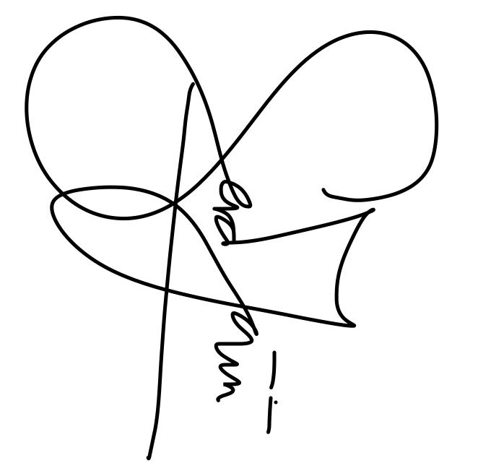

Print name: Izzati Norzaini

For and on behalf of the Recipient